Assignment 9
Title: Simulation of Finding Paths in a City Map using BFS and DFS

Name: Soham Ajit Puri
Roll. No: 04
Branch: CSDS_C1

Problem Statement: The objective of this assignment is to simulate path finding in a city map using Breadth-First Search (BFS) and Depth-First Search (DFS) algorithms. The city is represented as a graph, where each location such as Home, Park, School, Hospital, and Restaurant acts as a node, and the roads connecting them are represented as edges. The program aims to find the shortest path between two locations using BFS and any valid path using DFS, thereby demonstrating how different traversal methods explore routes and how these algorithms can be applied to real-world navigation and mapping systems.
Aim:
To design and implement a simulation that finds possible paths between locations in a city map using Breadth-First Search (BFS) and Depth-First Search (DFS) graph traversal algorithms.
Objectives:
- To represent a real-world map as a graph using an adjacency list.
- To implement and understand the working of BFS and DFS algorithms.
- To visualize how BFS finds the shortest path and DFS finds any possible path.
- To apply graph traversal concepts to real-world problems such as route finding, network navigation, and connection tracing.
Theory:
A graph is a data structure consisting of nodes (vertices) connected by edges. It is widely used to represent networks — such as maps, routes, or social connections.
In this assignment, each location (Home, Park, School, Hospital, Restaurant) is a node, and the roads between them are the edges.

The adjacency list representation is used to store these connections efficiently.
For example:
A: [B, C]
B: [D]
C: [E]
D: [E]
E: []

Here:
A connects to B and C
B connects to D
C connects to E
D connects to E
E has no outgoing connections

Thus, the graph represents a directed city map where movement is possible only along defined roads.

Graph Traversal Algorithms

Graph traversal means visiting all the nodes of a graph in a particular order.
Two of the most common traversal methods are Breadth-First Search (BFS) and Depth-First Search (DFS).

1. Breadth-First Search (BFS):
- BFS explores the graph level by level.
- It uses a queue data structure to remember the next vertex to visit.
- It guarantees finding the shortest path between the start and destination in terms of the number of edges.

Example:
If you start from Home (A) and want to reach Hospital (D), BFS ensures you reach D in the minimum number of steps.

2. Depth-First Search (DFS):
- DFS explores as deep as possible along a branch before backtracking.
- It uses a stack data structure (or recursion) to keep track of paths.
- DFS doesn’t guarantee the shortest path, but it quickly finds any valid path to the goal.

Example:
Starting from A, DFS may go A → B → D directly or may take A → C → E depending on the traversal order.

- Applications of BFS and DFS:

- GPS and route finding applications
- AI pathfinding in games and simulations
- Web crawling and network mapping
- Detecting connected components in networks

Analyzing social connections or friend recommendations
Algorithm:
Algorithm for BFS
Output: Find the shortest path from start to goal.

- Start from the starting location (e.g., A).
- Initialize a queue and put the first path [A] in it.
- While the queue is not empty:

  - Remove the first path from the queue.
  - Let last = last location in this path.
  - If last equals the goal (D), print the path and stop.
  - Otherwise, for each neighbor of last:
    - Create a new path by adding that neighbor to the current path.
    - Enqueue the new path.
- If the queue becomes empty and the goal is not found, print “No path found.”

Algorithm for DFS
Output: Find any possible path from start to goal.

- Start from the starting location (e.g., A).
- Initialize a stack and put the first path [A] in it.
- While the stack is not empty:
  - Pop the top path from the stack.
  - Let last = last location in this path.
  - If last equals the goal (D), print the path and stop.
  - Otherwise, for each neighbor of last:
    - Create a new path by adding that neighbor to the current path.
    - Push the new path into the stack.
- If the stack becomes empty and the goal is not found, print “No path found.”

CODE:
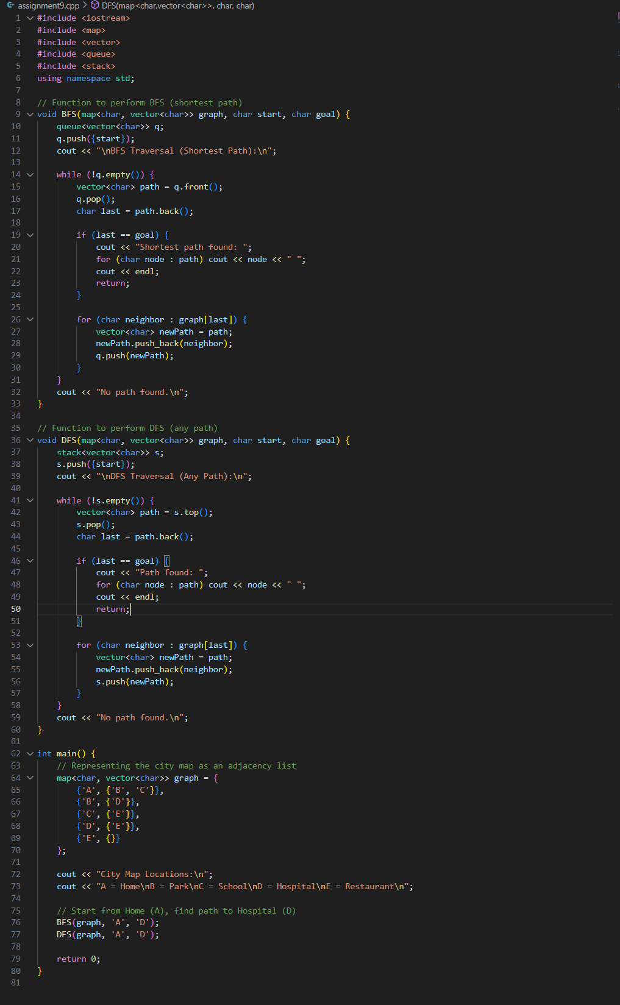
RESULTs:
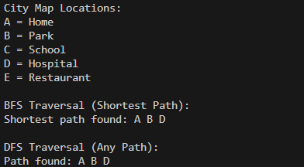

Complexity Analysis:

Algorithm | Time Complexity | Space Complexity | Description
BFS | O(V + E) | O(V) | Visits every vertex and edge once; ensures shortest path.
DFS | O(V + E) | O(V) | Visits all vertices and edges; explores deeply before backtracking.
Where V is the number of vertices (locations) and E is the number of edges (connections).

Conclusion:
In this experiment, we simulated path finding in a city map using Breadth-First Search (BFS) and Depth-First Search (DFS) algorithms.
BFS successfully identified the shortest path between two locations, while DFS found any valid path between the same points.

This experiment enhanced the understanding of how traversal techniques work in graphs and how they apply to real-world route mapping and navigation systems.
By representing the map as a graph, we could efficiently explore possible routes, demonstrating the power of graph-based problem solving in computer science.

